**Working of UART SERIAL CONNECTION BETWEEN TWO ARDUINO UNO OR ARDUINO MEGA:**

**TASK ON HAND:**

We are required to code both Arduino for Sending and Receiving data (STRING) using UART Protocol.

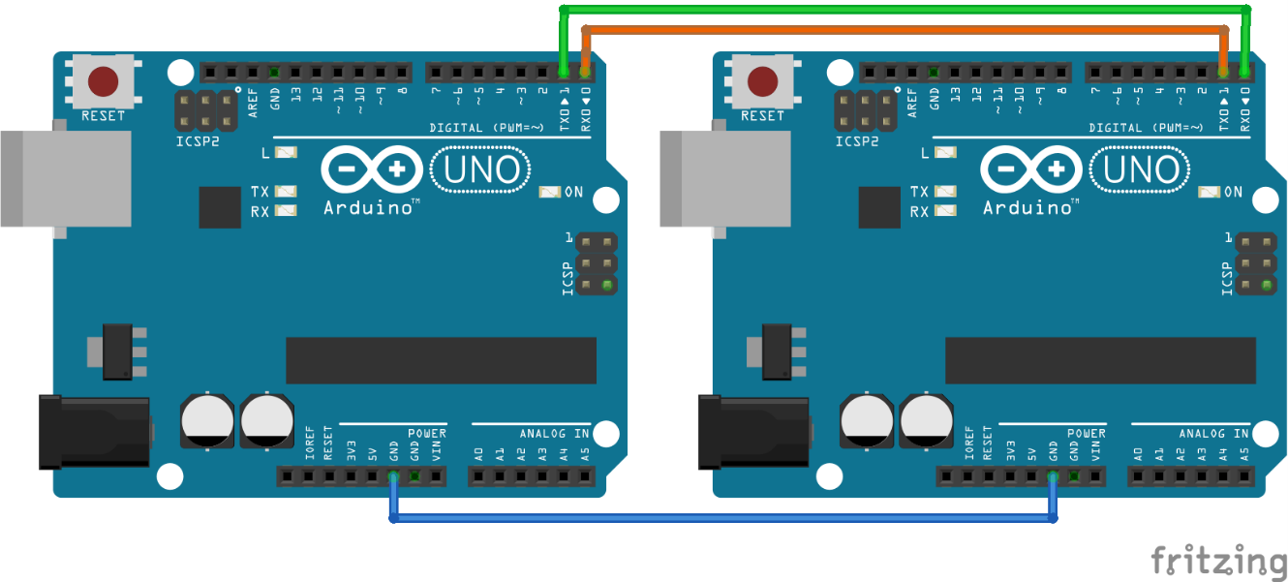

**BASIC CONCEPT:**

Arduino UART protocol communication is a way to communicate two Arduinos to send and receive data. This can be very useful for specific purposes.

**Requirements:**

Common Ground Both Arduino,

Connect RX and TX of one Arduino to TX and RX of other Arduino for communication purposes.

Connect both Arduinos simultaneously to PC .

**Important:** While uploading code on Arduino disconnect RX and TX pins of both Arduino since it is serially communicating with Serial Monitor first. After uploading code again connect pins to RX and TX of respective Arduino.